BEST Project Kicks Off: A New International Chapter for Higher Education in Cambodia and Vietnam
The Erasmus+ co-funded BEST Project (Boosting Excellence in Second-Tier HEIs) officially launched with a successful Kick-off Meeting held on December 9-10, 2024, at the University of Rome Tor Vergata, Italy. The project, part of the Capacity Building in Higher Education (CBHE) initiative, aims to strengthen second-tier Higher Education Institutions (HEIs) in Cambodia and Vietnam by enhancing internationalization, governance and institutional capacity.
Running from November 1, 2024 to October 31, 2027, the BEST Project brings together 8 partners from 5 EU and non-EU countries:
- University of Rome Tor Vergata (UNITOV), Italy
- University of Piraeus (UNIPI), Greece
- Institut de Haute Formation aux Politiques Communautaires (IHF), Belgium
- Ho Chi Minh City University of Banking (HUB), Vietnam
- University of Finance and Business Administration (UFBA), Vietnam
- Cambodia-Asia Polytechnic Institute (CAPI), Cambodia
- Angkor University (AU), Cambodia
Empowering Institutions for a Global Future – The BEST Project focuses on equipping HEIs with the tools needed to thrive in global academic networks. Key areas of action include:
- ✅ Building global partnerships
- ✅ Improving institutional governance
- ✅ Enhancing curriculum and research internationalization
- ✅ Developing mobility strategies
- ✅ Upgrading technology in International Relations Offices (IROs)
Kick-off Meeting Highlights – During the two-day meeting, participants from all partner institutions collaborated to align the project’s vision and action plan. The agenda featured a mix of strategic discussions and workshops, including:
- Project Overview and Work Package Presentations: UNITOV and other partners outlined their responsibilities and timelines for project implementation
- Capacity-Building Workshops: Sessions explored administrative tasks related to equipment management, the formation of working groups and the planning of project mobility activities for cross-border cooperation
- Technical and Financial Management: UNITOV and IHF led a detailed session on reporting requirements, financial guidelines and quality assurance to ensure smooth operations across all work packages
- Roundtable Discussions: Partners shared insights on the challenges and opportunities for HEIs in Cambodia and Vietnam, highlighting the updated and on-field needs for stronger international connections
The meeting concluded with a team-building session and cultural activities, here is showed some group photos with all delegations to celebrate the project’s official launch.
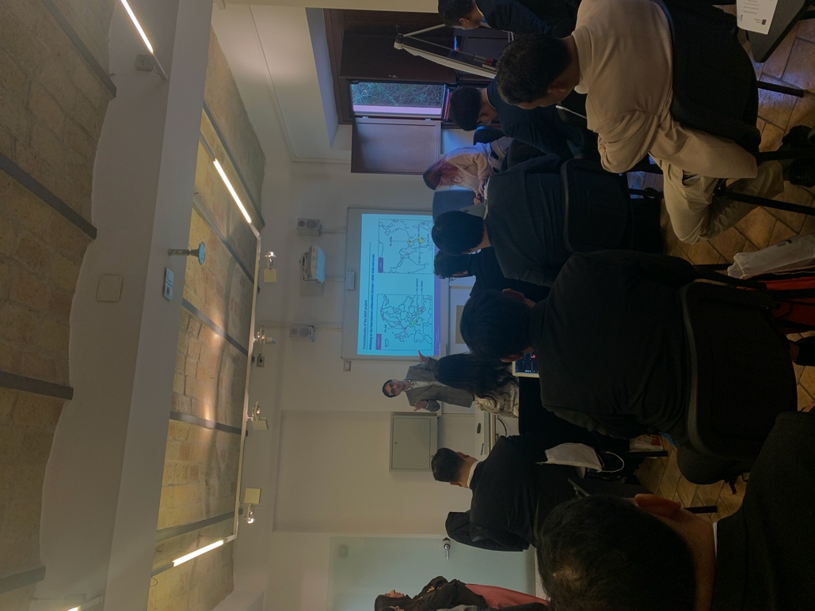
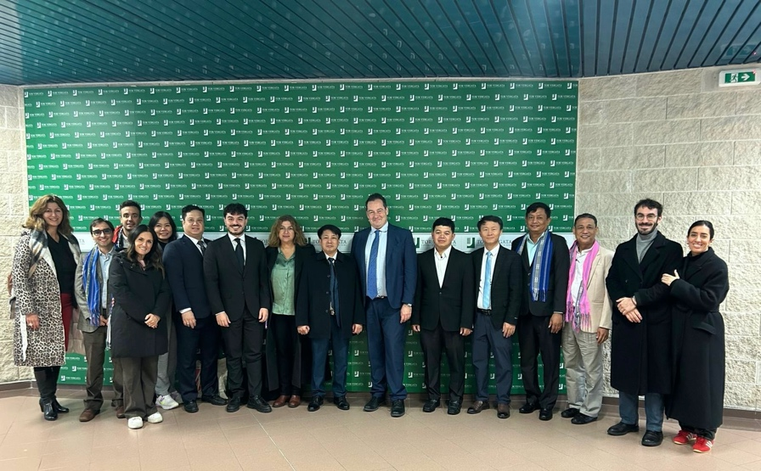
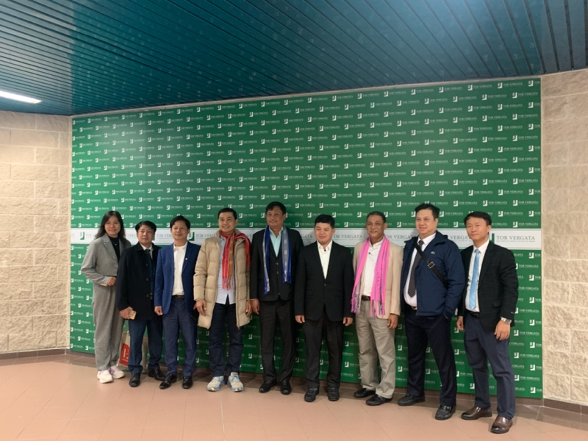
Looking Ahead – The BEST consortium will now focus on implementing capacity-building initiatives, supporting HEIs in developing internationalization strategies, and preparing for upcoming milestones. Follow-up meetings and training mobilities are planned for 2025 in Rome, Brussels and Athens to monitor progress and strengthen collaboration among partners.
Stay updated on the BEST Project’s milestones as we work towards transforming higher education in Cambodia and Vietnam.
About Erasmus+ CBHE – The Capacity Building in Higher Education (CBHE) initiative under Erasmus+ programme supports international collaboration to modernise higher education institutions, improve governance and promote innovation in partner countries. Views and opinions expressed are however those of the author(s) only and do not necessarily reflect those of the European Union or the European Education and Culture Executive Agency (EACEA). Neither the European Union nor EACEA can be held responsible for them.
For press inquiries and more information, please contact:
- Project’s mail: best.cbhe@gmail.com
- Dr. Christina Kontogoulidou, Scientific Coordinator, I.R.O., UNIPI, ckonto@unipi.gr

